INF407: Modern Issues in Databases
M3-1 Assignment– Inserting New Data Into an Environment: Understanding Options
Niharika jakkula

Part1:
Original data has: 510,000,
Module 1: added 5 rows 510,005,
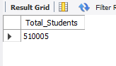
Query used:
INSERT INTO Student
(ID, Name_First, Name_Last, Birth_Dt, Major, Advisor_ID, Address_ID)
VALUES
(515006, 'niha', 'jakkula', '2000-01-01', 'Chemistry', NULL, NULL),
(515007, 'Mary', 'Johnson', '2001-02-02', 'Statistics', NULL, NULL),
(515008, 'carol', 'Brown', '1999-03-03', 'Education', NULL, NULL),
(515009, 'Sara', 'tendulkar', '2000-04-04', 'Knitting', NULL, NULL),
(515010, 'Chris', 'nives', '2001-05-05', 'Dance', NULL, NULL),
(515011, 'Nina', 'Taylor', '1998-06-06', 'Biology', NULL, NULL),
(515012, 'James', 'jimmy', '2000-07-07', 'Informatics', NULL, NULL),
(515013, 'niveditha', 'Thomas', '2001-08-08', 'ComputerScience', NULL, NULL),
(515014, 'luthra', 'Martin', '1999-09-09', 'CyberSecurity', NULL, NULL),
(515015, 'Emma', 'boven', '2000-10-10', 'Engineering', NULL, NULL);
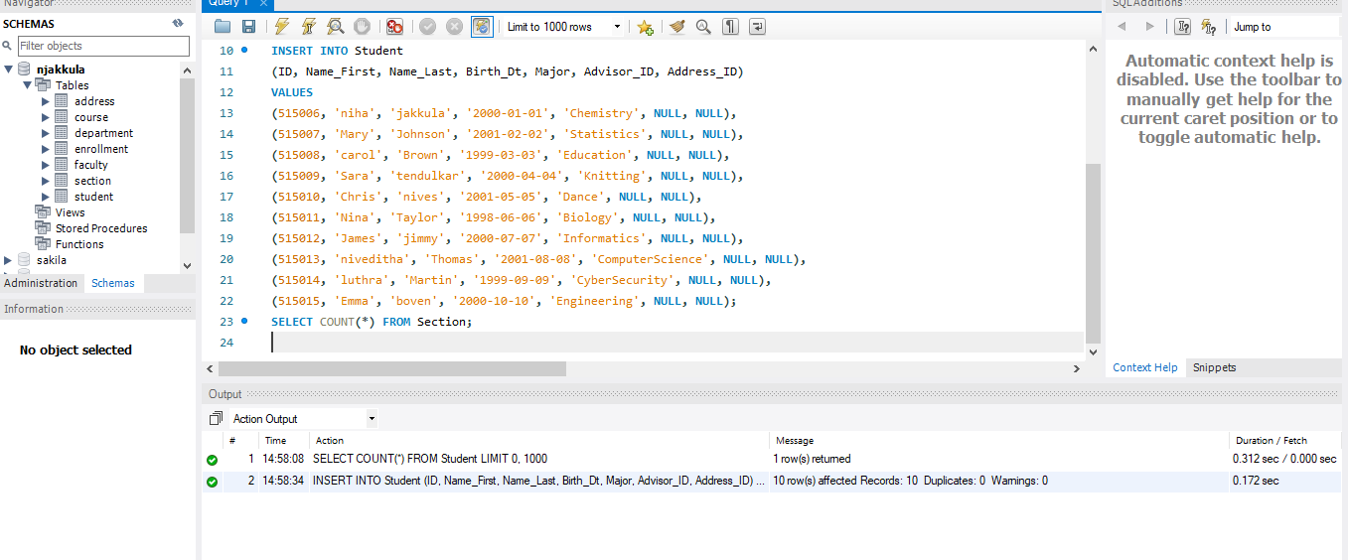 Execution Time: 0.172 sec
After adding 10 rows total : 510015.
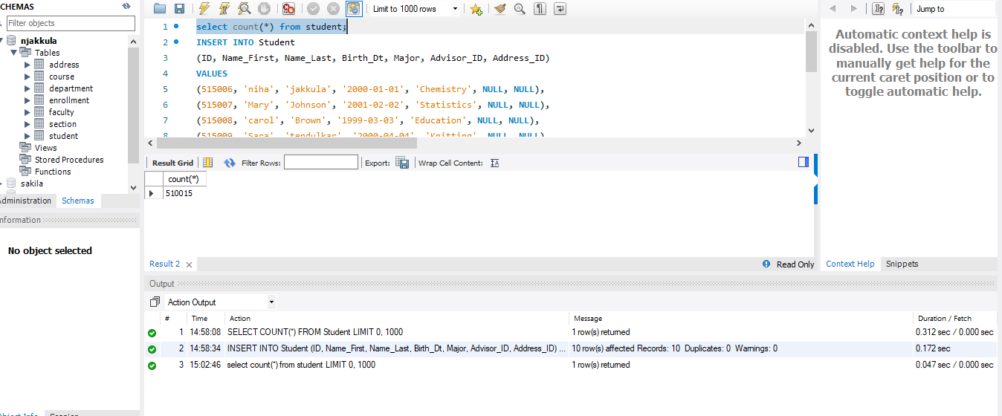

Part :2
Original count has: 5255,
Module 1: added 5 rows: 5260.
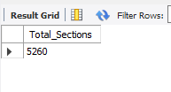
Query used: TRUNCATE TABLE Section;
Execution Time: 0.047
Screenshot:
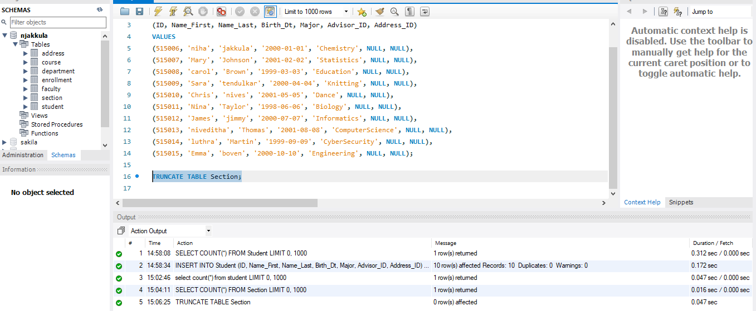
Successfully section table rows were deleted:
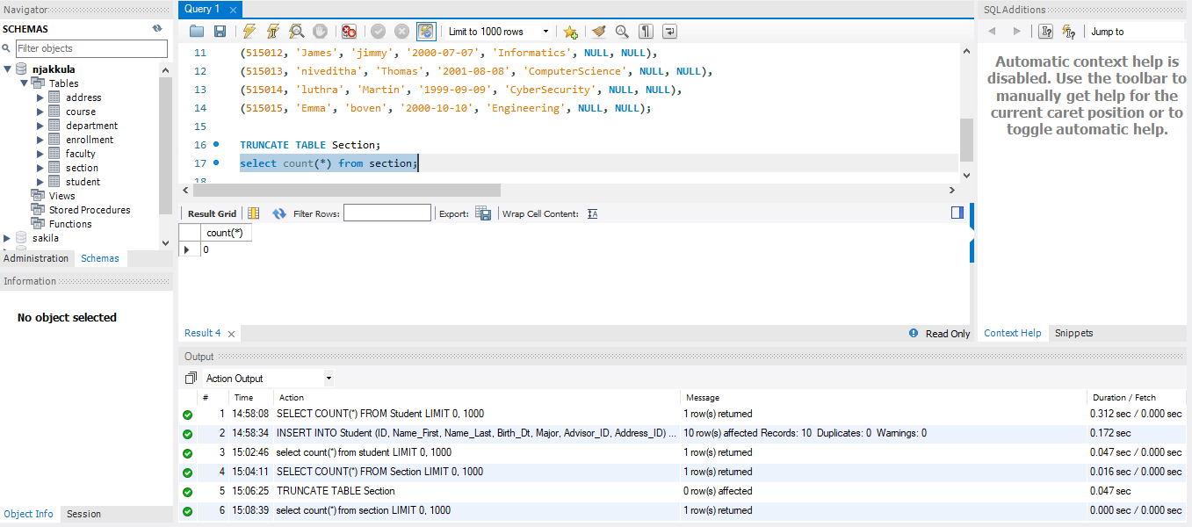
Reinserting the data into section using module-1.
Execution Time: ~0.015 sec

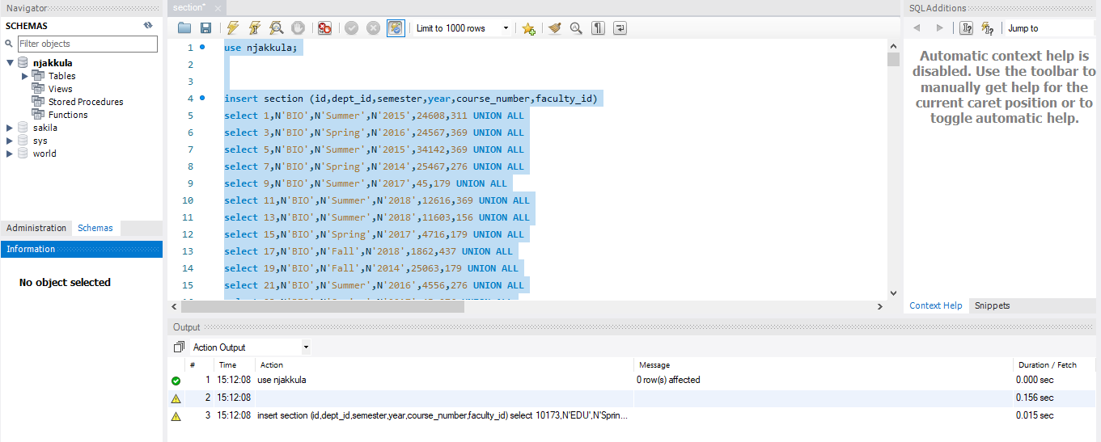
Sucessfully reinserted data into section table:
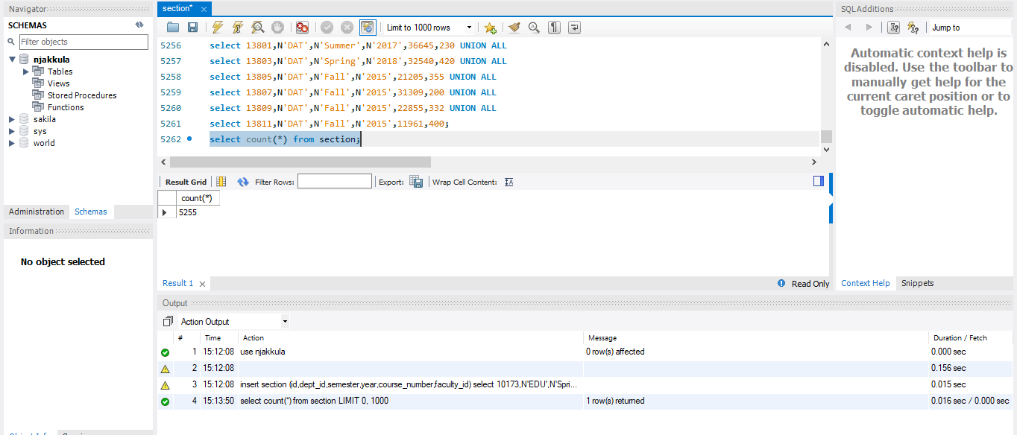
Summary:
In this assignment, I performed three operations: inserting records into the Student table, truncating the Section table, and reinserting data into the Section table. Based on the execution times observed in my screenshots, the Student insert operation took the most time at 0.172 seconds compared to the other operations. This is because each row inserted into the Student table must be validated against constraints such as primary keys, and the indexes must be updated accordingly. These validation and indexing steps increase the overall execution time when compared to the other operations.
For Part 2, in the Section table, the truncate operation took more time (0.047 seconds) compared to the insert operation (0.015 seconds). Although truncate is generally considered fast, it still performs additional internal work. Even though the table structure remains the same and only the rows are removed, truncate resets the table to an empty state, updates table information, and resets the table while maintaining index structure. These extra steps add overhead and increase execution time.
After TRUNCATE, the table becomes empty, and the index structures remain but contain no data. which allows the database to insert data more efficiently. Since there is no existing data, the database can build both the data and indexes from scratch without additional overhead. As a result, the Section insert operation was the fastest among the three operations.
Overall, this assignment shows that execution time depends not only on the type of operation but also on indexing, table state, and internal database processes.
When to Use INSERT, TRUNCATE, and REINSERT
INSERT INTO is appropriate when we want to add new records to a table without removing the existing data. For example, when a new student joins a university, their details can be added to the Student table using an insert operation.
TRUNCATE TABLE is appropriate when we want to remove all records from a table quickly while keeping the table structure the same. For example, if we want to clear old data from a table before loading fresh data, truncate can be used.
Reinserting data after truncating is appropriate when we want to reload a clean dataset into the table. For example, when restoring original data provided in a module or when reloading data from a dataset file after clearing the table.

